Electricity - 02
CLASS 10 - SCIENCE

 | Section A
1 | Which of the following statements about the current in given circuit is correct? 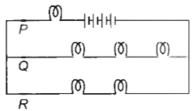  a) R has maximum current.  b) Current at Q is greater than the current at R.  c) P has maximum current.  d) Current at R is greater than the current at P. | [1]
2 | Consider the room temperature is 24°C in summer, the electrical resistance of thermocoil which is used in the AC unit is 150$Ω$ . Then calculate the temperature of the thermocoil if the electrical resistance is 175 $Ω$ . Given the temperature coefficient of the thermocoil is 2.98 $×$ 10 $​^{−4}$ °C $​^{−1}$  a) 583 °C  b) 512 °C  c) 597 °C  d) 546 °C | [1]
3 | A piece of wire of resistance R is cut into five equal parts. These parts are then connected in parallel. If the equivalent resistance of this combination is R’, then the ratio R/R’ is:  a) 1/25  b) 5  c) 25  d) 1/5 | [1]
4 | Electrical resistivity of a given metallic wire depends upon  a) its length  b) its shape  c) its thickness  d) nature of the material | [1]
5 | The resistivity of copper metal depends on only one of the following factors. This factor is:  a) Thickness  b) Temperature  c) Length  d) Area of cross - section | [1]
6 | If the potential difference between the ends of a fixed resistor is halved, the electric power will becomes:  a) half  b) double  c) one - fourth  d) four times | [1]
7 | If the area of cross - section of a resistance wire is halved, then its resistance becomes:  a) 4 times  b) One - half  c) 2 times  d) One - fourth | [1]
8 | When the area of cross - section of a conductor is doubled, its resistance becomes:  a) Half  b) Four times  c) Double  d) One - fourth | [1]
9 | The substance having infinitely high electrical resistance is called:  a) Conductor  b) Insulator  c) Resistor  d) Superconductor | [1]
10 | A cylindrical conductor of length land uniform area of cross - section Ahas resistance R. Another conductor of length 2.5 l and resistance 0.5 R of the same material has area of cross - section  a) 2.5 A  b) 5 A  c) $\frac{1}{5}$ A  d) 0.5 A | [1]
11 | How much resistance does a superconductor have?  a) Considerable resistance  b) Low resistance  c) High resistance  d) Zero resistance | [1]
12 | The resistance of the conductor is R. If the length is doubled by stretching the wire, then its new resistance will be :  a) R  b) 4R  c) 8R  d) 2R | [1]
13 | The unit of resistivity is  a) ohm - m  b) mho  c) ohm  d) ohm/m | [1]
14 | Which of the following does not apply to silver?  a) The movement of electrons on their outer most orbital is tightly held together.  b) The resistance provided is directly proportional to its length.  c) Their resistivity is in the range 10$​^{−8}$ $Ω$ to 10 $​^{−6}$ $Ω$ .  d) The resistance provided is inversely proportional to the area of cross section. | [1]
15 | The resistivity of a metallic wire depends on:  a) Its shape  b) Its thickness  c) Nature of material  d) Its length | [1]
16 | When the diameter of a wire is doubled, its resistance becomes:  a) Double  b) Four times  c) One - fourth  d) One - half | [1]
17 | The heat produced by passing an electric current through a fixed resistor is proportional to the square of:  a) time for which current is passed  b) magnitude of resistance of the resistor  c) temperature of the resistor  d) magnitude of current | [1]
18 | A potential difference of 20V is applied across the ends of a resistance of 5 ohms. What current will flow in the resistance?  a) 20A  b) None of these  c) 5A  d) 4A | [1]
19 | If the resistance of a certain copper wire is 1$Ω$ , then the resistance of a similar nichrome wire will be about:  a) 45$Ω$  b) 60$Ω$  c) 30$Ω$  d) 25$Ω$ | [1]
20 | A piece of wire of resistance 20$Ω$ is drawn out so that its length is increased to twice its original length. Resistance of the wire in the new situation:  a) 70$Ω$  b) 50$Ω$  c) None of these  d) 80$Ω$ | [1]
21 | Keeping the potential difference constant, the resistance of a circuit is doubled. The current will become:  a) Four times  b) Half  c) One - fourth  d) Double | [1]
22 | Which of the following is/are good conductor(s) of electricity?  a) Mica, Quartz  b) Metals, Mica  c) Metals, Quartz  d) Metals, Rubber | [1]
23 | A voltmeter and an ammeter are connected in series to an ideal cell of emf E. If the voltmeter reading is V, and the ammeter reading is I. Then  - V < E  - The voltmeter resistance is$\frac{V}{I}$  - The potential difference across the ammeter is (E - V)  - Voltmeter resistance + ammeter resistance =$\frac{E}{I}$  a) III and IV  b) I and II only  c) II and III only  d) I, II, III, IV | [1]
24 | The resistivity of the conductor doesnot depend upon its length or thickness because it is the:  a) Independent to thickness  b) Independentto length  c) Nature of material  d) Depends upon altitude | [1]
25 | If the diameter of a resistance wire is halved, then its resistance becomes:  a) One - fourth  b) Two times  c) Half  d) Four times | [1]
26 | The resistance of the wire when the length of the wire increases two times:  a) Becomes 3 times  b) Becomes 6 times  c) Becomes 4 times  d) Becomes 2 times | [1]
27 | A cylindrical conductor of length l and uniform area of cross section A has resistance R. Another conductor of length 2Iand resistance R of the same material has area of cross section.  a) 3A/2  b) 2A  c) A/2  d) 3A | [1]
28 | Which of the following is the most likely temperature of the filament of an electric light bulb when it is working on the normal 220 V supply line?  a) 2500°C  b) 1500°C  c) 500°C  d) 4500°C | [1]
29 | The resistivity does not change if  a) the shape of the resistor is changed  b) the temperature is changed  c) both material and temperature are changed  d) the material is changed | [1]
30 | For verifying Ohm’s law, we design an electric circuit diagram in which we show the arrangement of different circuit components. We find that with respect to the resistor, the:  a) ammeter and voltmeter are both connected in parallel.  b) ammeter and voltmeter are both connected in series.  c) ammeter is connected in parallel and the voltmeter in series.  d) ammeter is connected in series and the voltmeter in parallel. | [1]
31 | A battery of 9V is connected in series with resistors of 0.2$Ω$ , 0.3 $Ω$ , 0.4 $Ω$ , 0.5 $Ω$ , and 12 $Ω$ . How much current would flow through the 12 resistors?  a) 0.2 amp  b) 0.61 amp  c) 0.67 amp  d) None of these | [1]
32 | If 3 resistances of 3 ohm each are connected in parallel, what will be their total resistance?  a) 1$Ω$  b) 3$Ω$  c) 2$Ω$  d) None of these | [1]
33 | How will be the reading in the ammeter A affected if another identical bulb Q is connected in parallel to P? (The voltage in the mains is maintained at a constant value.) 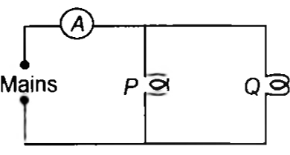  a) The reading will be reduced to one - half.  b) The reading will not be affected.  c) The reading will be increased four - fold.  d) The reading will be doubled. | [1]
34 | There are three resistors connected in parallel, the resistance of each resistor is 3 ohm. What is the total resistance of all the three resistors?  a) 3 ohm  b) 6 ohm  c) 15 ohm  d) 1 ohm | [1]
35 | Which among the following is the correct way connecting ammeter and voltmeter in the circuit to determine the equivalent resistance of two resistors in series?  a) Both ammeter and voltmeter in parallel  b) Ammeter in series and voltmeter in parallel  c) Ammeter in parallel and voltmeter in series  d) Both ammeter and voltmeter in series | [1]
36 | A wire that has resistance R is cut into two equal pieces. The two parts are joined in parallel. What is the resistance of the combination?  a) $\frac{R}{2}$  b) $\frac{R}{6}$  c) $\frac{R}{4}$  d) None of these | [1]
37 | Say switches S$​_{1}$ , S $​_{2}$ and so on up to S $​_{6}$ are closed at regular intervals of 2 minutes starting from t = 0. The graph of current I(in ampere) versus time t (in minute) is best represented as 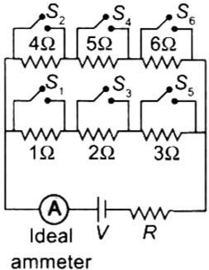  a) 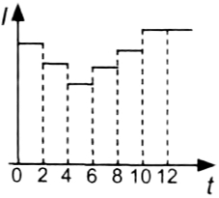  b) 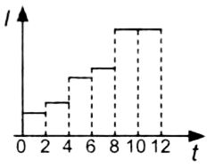  c) 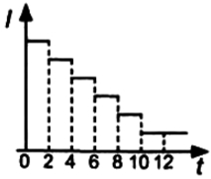  d) 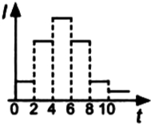 | [1]
38 | If a person has five resistors each of value$\frac{1}{5}Ω$ , then the maximum resistance he can obtain by connecting them is  a) 25$Ω$  b) 1$Ω$  c) 5$Ω$  d) 10$Ω$ | [1]
39 | The lamps in a household circuit are connected in parallel because:  a) this way they required less current  b) if one lamp fails the others also fail  c) if one lamp fails the others remain lit  d) this way they require less power | [1]
40 | Two LED bulbs of 10W and 5W are connected in series. If the current flowing through 5W bulb is 0.005A, the current flowing through 10W bulb is:  a) 0.0025A  b) 0.005A  c) 0.02A  d) 0.01A | [1]
41 | A 4$Ω$ coil and a 2 $Ω$ coil are connected in parallel. What is their combined resistance? A total current of 3A passes through the coils. What current passes through the 2 $Ω$ coil?  a) 4 A  b) None of these  c) 2 A  d) 1 A | [1]
42 | What possible values of resultant resistance one can get by combining two resistances, one of value 2 ohm and the other 6 ohm?  a) 8 ohm  b) 5 ohm  c) 10 ohm  d) None of these | [1]
43 | In which of the following network of resistors the equivalent resistance between points A and B is highest? 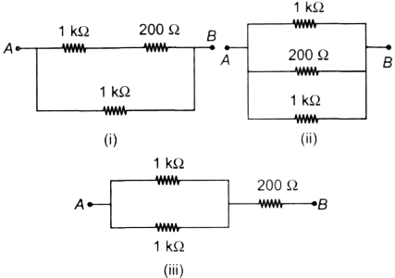  a) All have equal equivalent resistance.  b) Network (iii)  c) Network (i)  d) Network (ii) | [1]
44 | If four identical resistors, of resistance 8 ohm, are first connected in series so as to give an effective resistance R$​_{s}$ , and then connected in parallel so as to give an effective resistance R $​_{p}$ , then the ratio $\frac{R_{s}}{R_{p}}$ is  a) 16  b) 32  c) 2  d) 0.5 | [1]
45 | Two resistors of resistance 2$Ω$ and 4 $Ω$ when connected to a battery will have  a) same current flowing through them when connected in series  b) same potential difference across them when connected in series  c) different potential difference across them when connected in parallel  d) same current flowing through them when connected in parallel | [1]
46 | The potential difference in a circuit in which components are connected in parallel:  a) Gets divided across each component  b) Potential difference does not appear  c) Gets distributed equally  d) Remains the same across each component | [1]
47 | R$​_{1}$ and R $​_{2}$ are two resistors and r $​_{1}$ and r $​_{2}$ are equivalent resistances in series and parallel respectively, then $\frac{R_{1}}{R_{2}}$ =  a) $\frac{r_{1}r_{2}}{r_{1}+r_{2}}$  b) $\frac{r_{1}+r_{2}}{r_{1}r_{2}}$  c) $\frac{r_{1}+\sqrt{r_{1}−4r_{1}r_{2}}}{r_{1}−\sqrt{r_{1}−4r_{1}r_{2}}}$  d) $\frac{r_{1}+\sqrt{r_{1}−4r_{1}r_{2}}}{r_{1}+\sqrt{r_{1}+4r_{1}r_{2}}}$ | [1]
48 | The accumulator which is used for the domestic purpose has the electromotive force of 10 V and with an internal resistance of 0.8$Ω$ is externally charged by 150 V of the direct current power supply using a series resistor 18 $Ω$ . Calculate the terminal voltage of the accumulator during accusing.  a) 17.1 V  b) 16.8 V  c) 11.3 V  d) 15.9 V | [1]
49 | When a number of resistors are connected in series total resistance is equal to:  a) Inversely proportional resistances  b) Sum of individual resistance  c) Product of resistance  d) Difference of resistance | [1]
50 | Six equal resistances are connected between points P, Q and R as shown in the figure. The net resistance will be maximum between 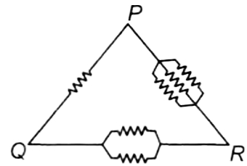  a) P and Q  b) P and R  c) Any two points.  d) Q and R | [1]
51 | The maximum resistance which can be made using four resistors each of 2$Ω$ is  a) 2$Ω$  b) 16$Ω$  c) 8$Ω$  d) 4$Ω$ | [1]
52 | When a 4$Ω$ and 2 $Ω$ resistors are connected in series, the equivalent resistance will be:  a) > 6$Ω$  b) 6$Ω$  c) < 2$Ω$  d) < 4$Ω$ | [1]
53 | The bulb is linked to the accumulator of electromotive force 90 V, with insignificant internal resistance, where the three resistors are 3$Ω$ , 6 $Ω$ , and 9 $Ω$ are connected collaterally. Evaluate the current via each resistor and the total current drained from the accumulator.  a) 15 A  b) 30 A  c) 55 A  d) 75 A | [1]
54 | Four resistors 1$Ω$ , 2 $Ω$ , 6 $Ω$ , 12 $Ω$ are connected. The maximum value that can be obtained is:  a) <1$Ω$  b) 6$Ω$  c) 18$Ω$  d) 21$Ω$ | [1]
55 | A student has correctly set - up the circuit for finding the equivalent resistance of two resistors in parallel. Each terminal of each of the two resistors, in this circuit, would be connected to  a) at least four more components in the circuit.  b) at least two more components in the circuit.  c) only one more component in the circuit.  d) at least three more components in the circuit. | [1]
56 | What is the equivalent resistance between points P and Q in the given circuit diagram? 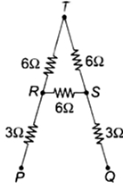  a) $\frac{10}{3}Ω$  b) $4Ω$  c) $5Ω$  d) $10Ω$ | [1]
57 | The resistors R$​_{1}$ , R $​_{2}$ , R $​_{3}$ and R4 in the given circuit are all equal in value and connected with a negligible resistance wire. Which of the following is correct relationship between the voltmeters readings V $​_{1}$ , V $​_{2}$ and V $​_{3}$ ? 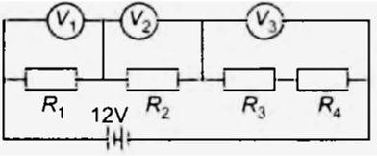  a) V$​_{1}$ = V $​_{2}$ < V $​_{3}$  b) V$​_{1}$ < V $​_{2}$ < V $​_{3}$  c) V$​_{1}$ = V $​_{2}$ > V $​_{3}$  d) V$​_{1}$ = V $​_{2}$ = V $​_{3}$ | [1]
58 | At a given time, a house is supplied with 100 A at 220 V. How many 75 W, 220 V light bulbs could be switched on in the house at the same times if they are all connected in parallel?  a) 93  b) 293  c) 193  d) 393 | [1]
59 | A wire of resistance R is cut into five equal pieces. These pieces are connected in parallel and the equivalent resistance of the combination is R’. Then the ratio$\frac{R}{R′}$ is:  a) 25:1  b) 5:1  c) 1:25  d) 1:5 | [1]
60 | When more than one resistors are in series, the quantity that remains same in them is  a) Potential difference  b) Ammeter  c) Resistance  d) Current | [1]
61 | The maximum resistance which can be made using four resistors each of resistance$\frac{1}{2}Ω$ is  a) 8$Ω$  b) 1$Ω$  c) 2.5$Ω$  d) 2$Ω$ | [1]
62 | The ammeter is used to measure the current flowing in the circuit. It is always connected in series with resistor because:  a) It has high resistance  b) It has low melting point  c) It has no resistance  d) It has low resistance | [1]
63 | The current drawn by ammeter is maximum if 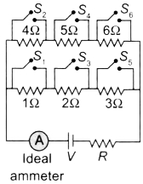  a) S$​_{2}$ , S $​_{4}$ , S $​_{5}$ closed  b) S$​_{1}$ ,S $​_{2}$ , S $​_{3}$ are closed  c) S$​_{1}$ ,S $​_{3}$ , S $​_{5}$ are closed  d) S$​_{2}$ , S $​_{3}$ , S $​_{4}$ closed | [1]
64 | The combination exhibiting series combination of resistors is  a) 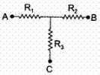  b) 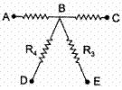  c) All of these  d) 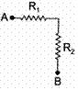 | [1]
65 | Two LED bulbs of 12W and 6W are connected in series. If the current through 12W bulb is 0.06A the current through 6W bulb will be:  a) 0.12A  b) 0.04A  c) 0.08A  d) 0.06A | [1]
66 | What is the maximum resistance which can be made using five resistors each of$\frac{1}{5}$ $Ω$ ?  a) 1$Ω$  b) $\frac{1}{5}$ $Ω$  c) 10$Ω$  d) 5$Ω$ | [1]
67 | What is the minimum resistance which can be made using five resistors each of 1/5$Ω$ ?  a) $\frac{1}{25}$ $Ω$  b) 25$Ω$  c) $\frac{1}{10}$ $Ω$  d) $\frac{1}{5}$ $Ω$ | [1]
68 | If two resistors of 25$Ω$ and 15 $Ω$ are joined together in series and then placed in parallel with a 40 $Ω$ resistor, the effective resistance of the combination is:  a) 0.1$Ω$  b) 10$Ω$  c) 20$Ω$  d) 40$Ω$ | [1]
69 | Find the current supplied by the source in figure. The resistors are mounted in a cylindrical form. 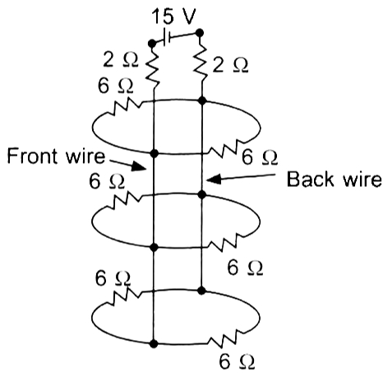  a) $\frac{14}{13}A$  b) 2 A  c) 3 A  d) 1.75 A | [1]
70 | Three resistances of 2$Ω$ , 3 $Ω$ and 5 $Ω$ are connected in parallel to a 10 V battery of negligible internal resistance. The potential difference across the three resistances will be:  a) 5 V  b) 10 V  c) 3 V  d) 2 V | [1]

